“Strikes for Fire Safety”
NFSA Empire Chapter
Charity Bowling Tournament to Support the Burn Center Through the Westchester Medical Center Foundation
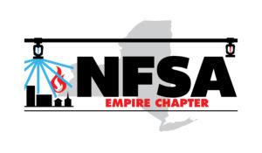
Tuesday, 29th of October
Prizes, Raffles, 50/50, Food and soft drinks, and COMPETITION! More details to follow!
Pricing available for individual bowlers and FIVE-somes! Gutter Guards not allowed!
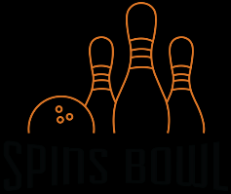
Location: Spins Bowl (https://www.spinsbowl.com/poughkeepsie-ny)
47 Taft Avenue
Poughkeepsie, NY 12603
Time: 12-2p Registration and LUNCH. 2-6p Tournament Bowling

NFSA Empire Chapter
Charity Bowling Tournament to Support the Burn Center through the Westchester Medical Center Foundation
REGISTRATION SHEETS (2 pages)

NAME _____________________________ COMPANY __________________________

E-Mail _____________________________ Cell# ________________________________

Sponsorships:
- Lane Sponsor $250
- Shoe Sponsor $300
- Ball Sponsor $350
- Lunch Sponsor $400
- Spare Sponsor $550- 1 Team of 5 + Lane Sponsorship
- Strike Sponsor $800- 2 Teams of 5 + Lane Sponsorship
- Perfect Game Sponsor- $ 1000- 2 Teams of 5 + Lane and Lunch Sponsorship+ Special Recognition during Awards Even
(cont’d on page 3)
NAME _____________________________

QTY __ Individual Bowler(s): $75/bowler

QTY____ FIVE-some(s): $325/5-some

QTY____ Sponsorship:___________________________________
$____________

$ _________TOTAL

Payment options:
- Online via www.paypal.me/nfsaempirechapter
- Check made out to NFSA Empire Chapter (memo: “2019 Bowling”) to:
SRI Fire Sprinkler LLC, Attn: Scott Enides, 1060 Central Ave, Albany, NY 12205

Additional Attendee Names from your company:

